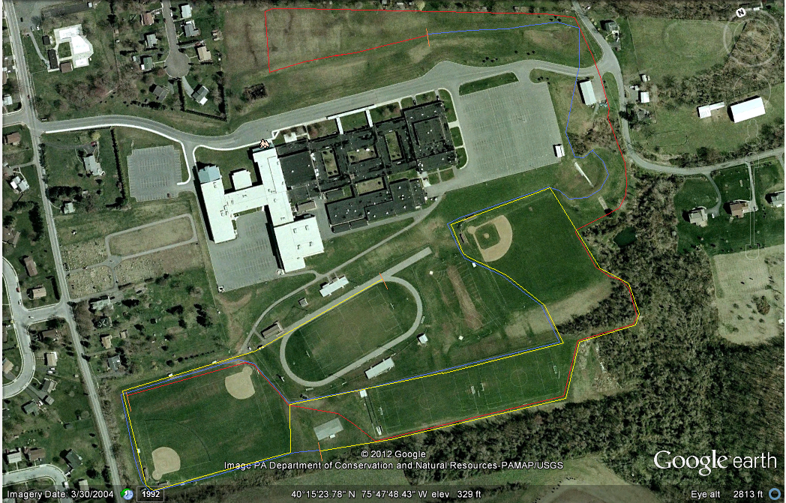
Key
Mile 1:
Mile 2:
Mile 3:
Finish
Start

