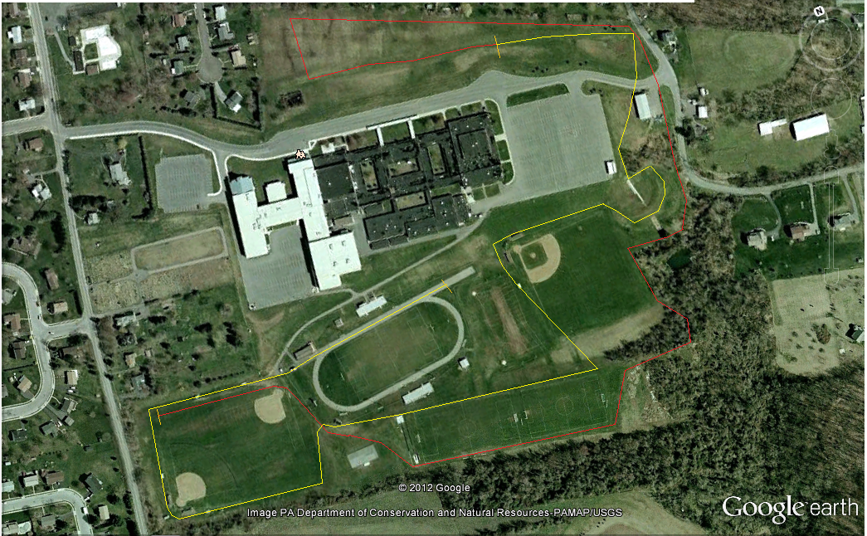

Finish

Start

Key

Mile 1:

Mile 2: